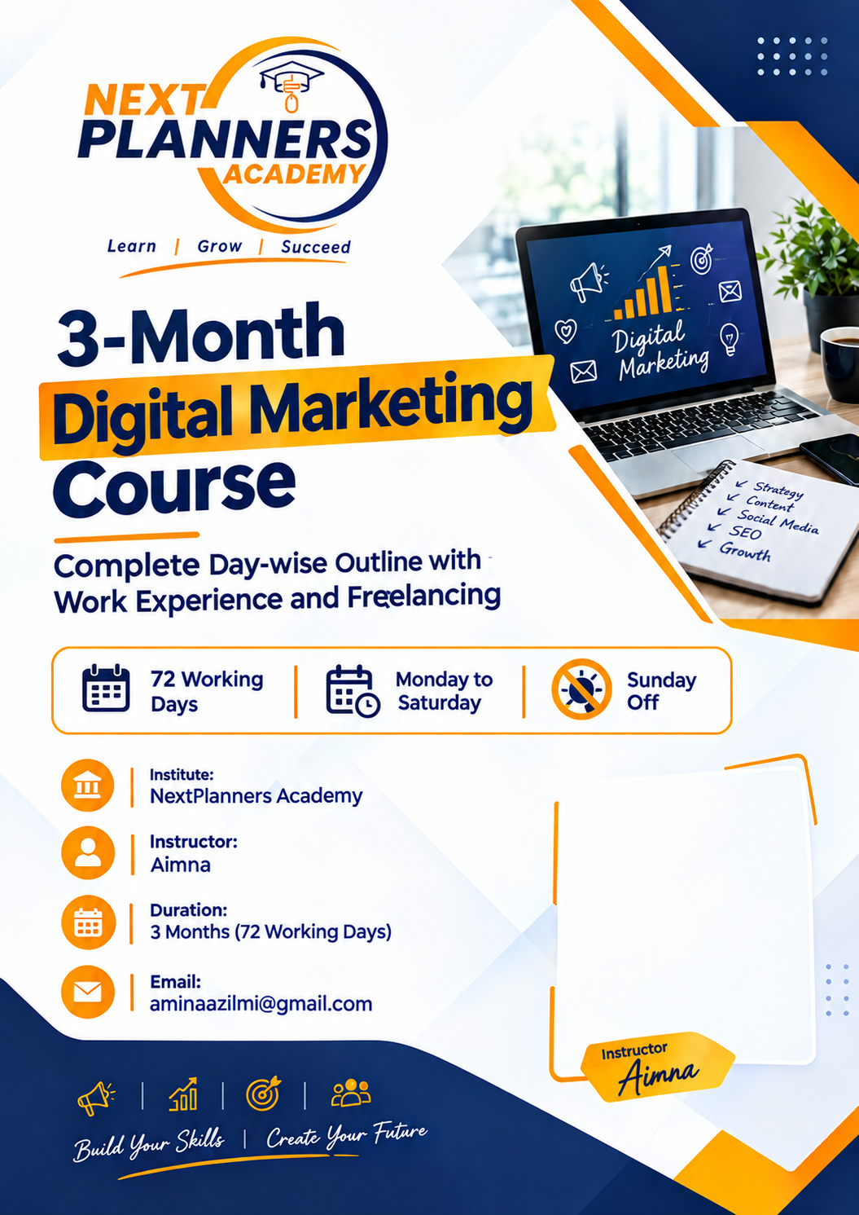
Table of Contents
Program Overview 3
Week-wise Calendar 5
Month 1: Foundations, AI Prompt Engineering, and Design 6
Week 1: Industry Introduction and Agency Setup 6
Week 2: Prompt Engineering and AI Platforms 6
Week 3: Canva Skills for Work 7
Week 4: Canva for Real Marketing Work 7
Month 2: Client Research, Content, and Social Media 8
Week 5: Client Research and Brand Understanding 8
Week 6: Content Planning Like a Professional 8
Week 7: AI-Powered Content Production 9
Week 8: Running Social Media Accounts 9
Month 3: Ads, SEO, Reporting, and Freelancing 10
Week 9: Paid Ads and SEO Foundations 10
Week 10: Local SEO, Email, and Reporting 10
The Last 15 Days: Freelancing Platform Work (Days 58 to 72) 12
Phase 1: Choose Services and Build Your Profile (Days 58 to 62) 12
Phase 2: Create Gigs, Portfolio, and Pricing (Days 63 to 66) 12
Phase 3: Find Clients and Send Proposals (Days 67 to 70) 13
Phase 4: Deliver Work, Get Paid, and Launch (Days 71 to 72) 13
What Students Take Home 14

Program Overview

About the Program
This is a three-month digital marketing program for beginners. Students learn like they work in a real marketing agency. Every day has a learning session and a work session, so students gain real skills and real work experience together.
The program covers Canva design, prompt engineering with AI tools, content planning, social media, paid ads, SEO, email marketing, client reporting, and freelancing. The last 15 days are fully focused on working on freelancing platforms.

About the Instructor
Aimna is the instructor of this program at NextPlanners Academy. She has three years of experience in digital marketing. You can contact her at aminaaziimi@gmail.com.

Program Details
Duration: 12 weeks, which is 72 working days.
Schedule: Monday to Saturday. Sunday is off.
Main tools: Canva, AI tools for prompt engineering, Meta Business Suite and Meta Ads Manager, Google tools for SEO and reporting, Google Drive and Sheets, Fiverr, Upwork, and LinkedIn.

What Students Will Learn

Month 1: Foundations, AI Prompt Engineering, and Design
In the first month students learn what digital marketing is and how an agency works. They then explore several AI platforms and learn prompt engineering first, so they can use AI to work faster in every later week. After that they learn Canva in detail, from design rules and brand kits to posts, stories, posters, thumbnails, and short videos.

Month 2: Client Research, Content, and Social Media
In the second month students research a client, its audience, and its brand, and give a practice client presentation in Canva. They then learn content strategy, content calendars, and caption writing, and use their AI skills to create ideas, captions, blogs, emails, and scripts. They also learn to set up and run social media pages and to schedule posts with Meta Business Suite.

Month 3: Ads, SEO, Reporting, and Freelancing
In the third month students learn paid ads, SEO, email marketing, analytics, and client reporting. The last 15 days are spent building freelancing profiles, creating gigs, sending proposals, and learning how to deliver work and get paid.

SEO Topics Covered
SEO is taught in several parts so students understand the full picture. They learn keyword research and search intent, on-page SEO (titles, meta descriptions, headings, URLs, image alt text, internal links, and content quality), technical SEO (mobile friendliness, page speed, sitemaps, indexing, and broken links), off-page SEO (backlinks, directories, and brand mentions), local SEO with Google Business Profile, using AI to support SEO writing, and tracking results in Google Search Console and basic analytics.

Tools and Technologies

Design
Canva is the main design tool. Students use templates, the brand kit, photo and video editing, reels, client presentations, and Canva's AI tools such as Magic Write and Magic Media.

AI and Prompt Engineering
Students explore several AI platforms, including ChatGPT, Claude, DeepSeek, Google Gemini, Microsoft Copilot, and Perplexity, and compare what each one does best. They learn the prompt formula of role, task, context, format, and tone, build a personal prompt library, and learn to check facts and edit AI text so it sounds natural.

Social Media Platforms
Students work with Facebook, Instagram, TikTok, LinkedIn, and YouTube, and use Meta Business Suite to schedule posts, reply to messages, and read insights.

Paid Advertising
Students use Meta Ads Manager to plan Facebook and Instagram ad campaigns, including goals, audiences, budgets, and ad creatives.

SEO and Search Tools
Students use Google Search, Google Trends, Google Keyword Planner, Google Search Console, Google Business Profile, and basic Google Analytics reports, along with AI tools for keyword and meta description ideas.

Email Marketing
Students plan and write newsletters, design email banners in Canva, and learn how free email tools such as Mailchimp are used to build lists and send campaigns.

Teamwork and Productivity
Students use Google Drive, Google Docs, and Google Sheets for files, content calendars, and reports, and Trello for task tracking. They also use WhatsApp Business and email for professional client communication.

Freelancing Platforms
Students create and manage profiles on Fiverr, Upwork, and LinkedIn, write gigs and proposals, and learn how safe payments and withdrawals work.

How the Program Works

Agency Setup
The class works like a small digital marketing agency. Students are placed in teams of four, and each team gets real or practice clients, such as a local shop, restaurant, school, or clothing brand.

Team Roles
The roles are account manager, graphic designer, content and AI writer, and social media and ads specialist. Students change roles every month so everyone learns every part of the work.

Daily Routine
Each day starts with a short team meeting. Then comes the learning session, followed by the work session. The day ends with a short progress note, just like in a real job.

Professional Habits
Students learn to meet deadlines, follow a client brief, take feedback politely, write professional messages, work in a team, and report results clearly.

Three Phases of the Program
Month 1 (Days 1 to 24): Foundations, AI prompt engineering, and Canva design.
Month 2 (Days 25 to 48): Client research and presentation, content, and social media.
Month 3 (Days 49 to 72): Ads, SEO, email, reporting, and the last 15 days of freelancing platform work.

Week-wise Calendar
Week | Days | Focus
Week 1 | 1 to 6 | Industry introduction and agency setup
Week 2 | 7 to 12 | Prompt engineering and AI platforms
Week 3 | 13 to 18 | Canva skills for work
Week 4 | 19 to 24 | Canva for real marketing work
Week 5 | 25 to 30 | Client research, brand understanding, and client presentation
Week 6 | 31 to 36 | Content planning like a professional
Week 7 | 37 to 42 | AI-powered content production
Week 8 | 43 to 48 | Running social media accounts
Week 9 | 49 to 54 | Paid ads and SEO foundations
Week 10 | 55 to 60 | Local SEO, email, reporting, and freelancing start
Week 11 | 61 to 66 | Freelancing profiles, gigs, and pricing
Week 12 | 67 to 72 | Proposals, client work, delivery, and final review
Classes run Monday to Saturday. Sunday is a weekly off day.

Month 1: Foundations, AI Prompt Engineering, and Design
Goal: Learn the basics, explore AI platforms and prompt engineering, and build strong Canva design skills.

Week 1: Industry Introduction and Agency Setup
Day | Weekday | Topic | Learning and Work Activity
1 | Monday | Orientation and workplace rules | Students learn how the program works and what is expected of them. Teams and roles are given.
2 | Tuesday | Digital marketing overview | Students learn the main channels. In the work session, each team studies one competitor business.
3 | Wednesday | How an agency works | Students learn about clients, briefs, deadlines, and deliverables, and practice reading a sample client brief.
4 | Thursday | Professional communication | Students learn to write client emails, WhatsApp messages, and meeting notes. They write a sample introduction email.
5 | Friday | Careers and freelancing | Students learn about jobs and freelance paths and set personal career goals.
6 | Saturday | Work review | Teams present their competitor study and get feedback.

Week 2: Prompt Engineering and AI Platforms
Day | Weekday | Topic | Learning and Work Activity
7 | Monday | What is AI and prompt engineering | Students learn in simple words what AI tools are, what a prompt is, and why a clear instruction gives a better answer.
8 | Tuesday | Exploring AI platforms: ChatGPT and Claude | Students create accounts, try the same prompt on both platforms, and compare the answers for quality, tone, and speed.
9 | Wednesday | Exploring AI platforms: DeepSeek, Gemini, Copilot, and Perplexity | Students try more platforms, compare their strengths, and learn which tool suits which task. They also learn about free and paid versions and why private client information should never be pasted into AI tools.
10 | Thursday | Prompt formula | Students learn role, task, context, format, and tone and practice by writing prompts for captions, slogans, and product descriptions.
11 | Friday | Fixing weak prompts and building a prompt library | Students learn to improve prompts step by step and start a personal prompt library of their best prompts to reuse in future jobs.
12 | Saturday | AI work review | Students compare their results across platforms, learn to check facts and remove errors, and decide which platform they will use for which kind of work.

Week 3: Canva Skills for Work
Day | Weekday | Topic | Learning and Work Activity
13 | Monday | Canva basics | Students learn the dashboard, templates, and tools.
14 | Tuesday | Design rules | Students learn colors, fonts, and layout, then redesign a poor design to make it better.
15 | Wednesday | Brand kit | Designers set up the client's brand kit in Canva.
16 | Thursday | Social media posts | Teams design three matching posts for the client.
17 | Friday | File handling | Students learn file types, proper file naming, and sharing files through Google Drive.
18 | Saturday | Design review | The teacher acts as the client and gives feedback, and students fix their designs.

Week 4: Canva for Real Marketing Work
Day | Weekday | Topic | Learning and Work Activity
19 | Monday | Stories and covers | Students design stories and cover photos for the client.
20 | Tuesday | Posters and flyers | Students design a poster or flyer for a client offer.
21 | Wednesday | Thumbnails and banners | Students make thumbnails and banners.
22 | Thursday | Reels and short videos | Students make a short promotional video in Canva.
23 | Friday | Revision round | Teams improve all work based on feedback.
24 | Saturday | Month 1 delivery | Each team delivers a brand kit and ten designs for its practice client and gets a performance review.

Month 2: Client Research, Content, and Social Media
Goal: Research a client and present the findings, then work like a content and social media team using AI tools to work faster and better.

Week 5: Client Research and Brand Understanding
Day | Weekday | Topic | Learning and Work Activity
25 | Monday | Client meeting practice | Students learn to ask clients the right questions and do a role-play meeting.
26 | Tuesday | Audience research | Teams research the target audience of their client. They use Google Trends and AI platforms to speed up research, and check every fact before using it.
27 | Wednesday | Customer profile | Teams create a customer profile for their client.
28 | Thursday | Brand analysis and presentation design | Students learn about brand voice, colors, and message, then review the client's current brand. Teams start building their client presentation in Canva.
29 | Friday | Marketing funnel, goals, and rehearsal | Students learn to set clear marketing goals and write goals for their client. Teams finish their slides and rehearse, with tips on speaking clearly and answering client questions.
30 | Saturday | Client presentation | Teams submit a one-page research report and present their findings to the "client" (the teacher) in a practice client presentation, then receive feedback.

Week 6: Content Planning Like a Professional
Day | Weekday | Topic | Learning and Work Activity
31 | Monday | Content strategy | Students learn how agencies plan content and write a content strategy for their client.
32 | Tuesday | Content types and goals | Students decide which content types fit the client's goals.
33 | Wednesday | Content calendar | Teams build a monthly content calendar in Google Sheets.
34 | Thursday | Caption writing | Students learn to write captions in the client's brand voice.
35 | Friday | Client approval process | Students learn how to send work for approval and handle changes.
36 | Saturday | Calendar presentation | Teams present their content calendar to the "client."

Week 7: AI-Powered Content Production
Day | Weekday | Topic | Learning and Work Activity
37 | Monday | A month of content with AI | Teams use prompts to create post ideas, hooks, and hashtags.
38 | Tuesday | Blogs, emails, and scripts | Students use AI for outlines and drafts.
39 | Wednesday | Human editing | Students edit AI text so it sounds natural and matches the brand. They also learn when not to use AI.
40 | Thursday | Advanced prompting | Students learn to give examples and build prompt templates for clients.
41 | Friday | AI with Canva | Students use Canva's AI tools with their own text and designs.
42 | Saturday | Production day | Teams complete one full week of ready-to-post content.

Week 8: Running Social Media Accounts
Day | Weekday | Topic | Learning and Work Activity
43 | Monday | Platform strategy | Students learn to choose the right platforms for each client.
44 | Tuesday | Page setup | Students set up or improve a Facebook and Instagram business page.
45 | Wednesday | Posting and growth | Students learn posting times, hashtags, and engagement.
46 | Thursday | Community management | Students learn to reply to comments and messages professionally.
47 | Friday | Meta Business Suite | Students schedule real posts and check insights.
48 | Saturday | Month 2 delivery | Teams submit a 30-day content calendar with captions and designs and get a performance review.

Month 3: Ads, SEO, Reporting, and Freelancing
Goal: Finish the agency skills, then spend the last 15 days working as real freelancers on live platforms.

Week 9: Paid Ads and SEO Foundations
Day | Weekday | Topic | Learning and Work Activity
49 | Monday | Ads basics and campaign setup | Students learn how Facebook and Instagram ads work, how to plan a budget, and how to choose a campaign goal and target audience in Meta Ads Manager.
50 | Tuesday | Ad copy and AI ad copy | Students write ad headlines and text, then use AI prompts to create several versions and choose the best ones to test.
51 | Wednesday | Ad designs and ad plan | Students make ad images and banners in Canva. Teams submit a full ad plan with budget, audience, copy, and designs.
52 | Thursday | SEO basics and keyword research | Students learn how search engines crawl, index, and rank pages. They find keywords for their client using Google Trends and Google Keyword Planner and learn the difference between short and long keywords and search intent.
53 | Friday | On-page SEO | Students learn how to improve a page itself: page titles, meta descriptions, headings, URLs, image alt text, internal links, and content quality. They use AI prompts to draft blog titles, meta descriptions, and keyword ideas, then edit them by hand.
54 | Saturday | Technical SEO and Google Search Console | Students learn what makes a website easy for search engines to read: mobile friendliness, page speed, sitemaps, indexing, and fixing broken links. They are introduced to Google Search Console to see clicks, impressions, and search errors.

Week 10: Local SEO, Email, and Reporting
Day | Weekday | Topic | Learning and Work Activity
55 | Monday | Off-page and local SEO | Students learn about backlinks, brand mentions, business directories, and social signals. They set up or improve a Google Business Profile with correct name, address, phone number, photos, and reviews so a local business shows up in map and nearby searches.
56 | Tuesday | Email marketing | Students learn how to build an email list and plan a newsletter. They write a newsletter and design the email banner in Canva.
57 | Wednesday | Analytics and client reports | Students learn to read reach, clicks, conversions, and basic SEO numbers such as impressions and rankings. Teams write a simple monthly client report with results and next steps.

The Last 15 Days: Freelancing Platform Work (Days 58 to 72)
Goal: Students stop practicing for clients and start working like real freelancers. By Day 72, every student has live profiles, a portfolio, sent proposals, and ideally their first order or client.
Platforms used are Fiverr, Upwork, LinkedIn, and local options such as Facebook business groups and WhatsApp business contacts.

Daily Routine for These Days
Each day has a learning session of about one hour, then a long work session on the student's own accounts. The day ends with a progress note recording gigs made, proposals sent, messages sent, and replies received.

Ground Rules
Students must use honest profiles and only show work they made themselves. No fake reviews, no copied portfolios, and no false claims about experience. New freelancers often wait a few weeks for the first order, so patience and steady effort matter.

Phase 1: Choose Services and Build Your Profile (Days 58 to 62)
Day | Weekday | Topic | Learning and Work Activity
58 | Thursday | How freelancing works | Students learn how Fiverr, Upwork, and LinkedIn work, how fees are taken, and how clients choose freelancers. They compare the platforms and decide where to start.
59 | Friday | Choosing your niche and services | Students learn why a clear niche beats "I do everything." Each student picks two or three services, such as Canva design, AI-assisted captions, content calendars, or Facebook page setup, and writes a short description for each.
60 | Saturday | Market research | Students study successful sellers in their niche, noting titles, prices, gig images, and reviews, and write a short report on what top sellers do well.
61 | Monday | Professional profile writing | Students write a strong headline, photo plan, and "About me" section. They use AI prompts for a draft, then edit it to sound natural and honest.
62 | Tuesday | Account setup | Students create and complete their Fiverr and Upwork accounts. Teachers cover account safety, strong passwords, and one account per person only.

Phase 2: Create Gigs, Portfolio, and Pricing (Days 63 to 66)
Day | Weekday | Topic | Learning and Work Activity
63 | Wednesday | Writing your first gig | Students write a gig title, description, three packages (basic, standard, premium), and FAQ, and learn simple search keywords.
64 | Thursday | Gig images and video | Students design gig cover images and a short intro video in Canva.
65 | Friday | Portfolio and sample work | Students upload their best course work. Those who need more samples create new ones for imaginary or friendly local businesses.
66 | Saturday | Pricing and publishing | Students learn to set starting prices, offer packages, and raise prices as they gain reviews. Each student publishes at least one gig and gets teacher feedback on all profiles.

Phase 3: Find Clients and Send Proposals (Days 67 to 70)
Day | Weekday | Topic | Learning and Work Activity
67 | Monday | Proposal writing | Students learn to read a job post, understand what the client wants, and write a short, personal proposal. They use AI for a first draft and rewrite it in their own voice.
68 | Tuesday | Applying for jobs | Students send real proposals on Upwork. The target is at least five good proposals, not copied and pasted.
69 | Wednesday | LinkedIn and direct outreach | Students improve their LinkedIn profiles, post about their services, and message local businesses with a polite first message and a follow-up.
70 | Thursday | Client communication | Students learn to reply to buyers, ask project questions, set deadlines, handle changes, and deal with difficult clients, with role-play practice.

Phase 4: Deliver Work, Get Paid, and Launch (Days 71 to 72)
Day | Weekday | Topic | Learning and Work Activity
71 | Friday | Delivery, reviews, and getting paid | Students learn to deliver on time, ask for honest reviews, handle payments and withdrawals safely, and keep income records. They also write a professional CV and finish their LinkedIn profile.
72 | Saturday | Final review and certificates | Each student shows their live profiles, gigs, portfolio, proposals sent, and any replies or orders. The teacher gives each student a personal improvement plan. Students receive a certificate, a work experience letter, and a 30-day action plan.

What Students Take Home

Work Experience Proof
Students leave with a brand kit and design portfolio, a content calendar, an ad plan, a client report sample, a personal prompt library, a professional CV, and live Fiverr, Upwork, and LinkedIn profiles with sent proposals.

Skills Gained
Students can design in Canva, write strong prompts for AI tools, plan content, run social media pages, create ad plans, understand basic SEO and email marketing, write client reports, find freelance clients, and communicate like a professional.

Targets by Day 72
A good target is one published gig per student, ten or more proposals or outreach messages, and at least one portfolio sample for every service offered.

Contact
Instructor: Aimna, NextPlanners Academy
Email: aminaaziimi@gmail.com

